**SPACE FOX**

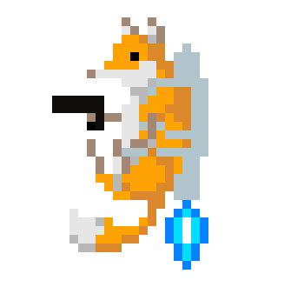

By Ethan Gregory

The genre of this game is a single player 2D shooter “endless runner.” A similar game is [*Jetpack Joyride*](https://youtu.be/OhU7tLtOIgE?t=194)*,* which is similar as the player controls a character with a jetpack who moves up and down and must dodge obstacles coming their way. In the case of SPACE FOX, the player takes control of a fox wearing a jetpack, who wields a laser gun.

The in-game obstacles consists of asteroids of different shapes. The player must last as long as possible to get a high score. The game will get more challenging as it goes on, as asteroids will appear faster and more frequently. The player’s score will gradually go higher the longer they survive. It’s an arcade-style game, as the goal is to last as long as possible to get the highest score as there isn’t a single “win condition.”

The fox the player controls has a laser gun which they can use to shoot the asteroids, destroying them. This will be vital if the player wants to last a long time. The player has three health points, if the player gets hit by an asteroid, they lose one health point. If they get hit three times, they get a game over, but their score is saved.

The main controls of the player consists of moving up and down to dodge asteroids coming their way, as well as a shoot button which shoots the player’s laser. The asset for the character the player controls can be found [here](http://pixelartmaker.com/art/61e78f9c445e4a1). I will add some animations to the character, as well as a laser that they shoot out. The asset for the asteroids can be found [here](https://assetstore.unity.com/packages/2d/environments/2d-pixel-asteroids-136477).

A walkthrough of the game is pressing start on the title screen, starting the game. The title screen displays the player’s high score. The player then needs to dodge or shoot asteroids coming their way, trying to avoid getting hit and losing health points. If the player is hit three times, they get taken to the game over screen and can see their current score and their high score. If the player presses enter, they are taken back into the game and can try again.

Time spent on features:

Player Object: ~7 minutes

Obstacle Object: ~5 minutes

Projectile Object: ~20 minutes  
Game Over screen: ~15 minutes

Spawner: ~25 minutes

Time spent on programming scripts:

DetectCollisions: ~15 minutes

Spawner: ~20 minutes

SpawnPoint: ~5 minutes

Movement: ~15 minutes

Obstacle: ~10 minutes

Player: ~50 minutes

GameOver: ~20 minutes

Features left to implement:

High score* (estimated 40 minutes)

Sprites (estimated 30 minutes)

Sounds (estimated 40 minutes)

Moving background (estimated 30 minutes)

Title screen (estimated 20 minutes)

Animations (estimated 40 minutes)